
Using Your 180° Servo with an LCD Keypad Shield

Overview:
This tutorial demonstrates how 180° servos work on Arduino boards and how to use them.
Materials:
This project requires an Arduino UNO (or compatible board), a 180° servo, an LCD keypad shield, a small breadboard, nine female/male jumper wires, five male/male jumper wires, and a computer with the Arduino IDE installed with a USB connector for the UNO.
Procedure:
1: Wire together the UNO, 180° servo and LCD keypad shield together according to figure 1.

fig. 1
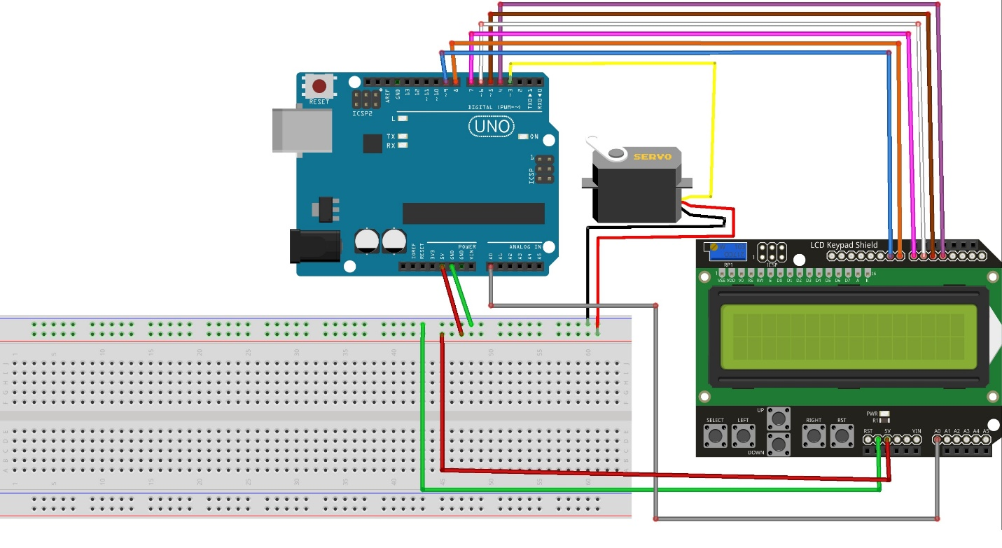

2: Go to www.rabbitrobots.com and download the servo tester program from the “Software” section.
3: Open the downloaded ServoTest.ino file with the Arduino IDE and upload it to the UNO.
4: Press the left, right, up, and down keys on the keypad to adjust the position of the servo.
5: Gently push the arm of the servo to see if it can be moved out of its set position.
6: Discover how far the servo can rotate left and right. This might not be a perfect 180° depending on the individual servo.
7: Determine the speed of the servo in RPM by measuring how long it takes for the servo to turn its full amount in seconds, and multiplying it by 120.

Code explanation:
The first section of the code (fig.2) imports the libraries needed to use the servo and LCD screen, define the program’s constants, declare variables used by the program, and declares the actual servo and LCD screen themselves. In this section, only “#include <Servo.h>” “int servoPosition = 0;” and “Servo myServo” actually deal with the function of the servo.

“#include <Servo.h>” imports the library of methods for using servos into the program to use; “int servoPosition = 0;” declares an integer starting at zero that will store the position for the servo later, and “Servo myServo;” declares the physical servo itself in the program.
fig. 2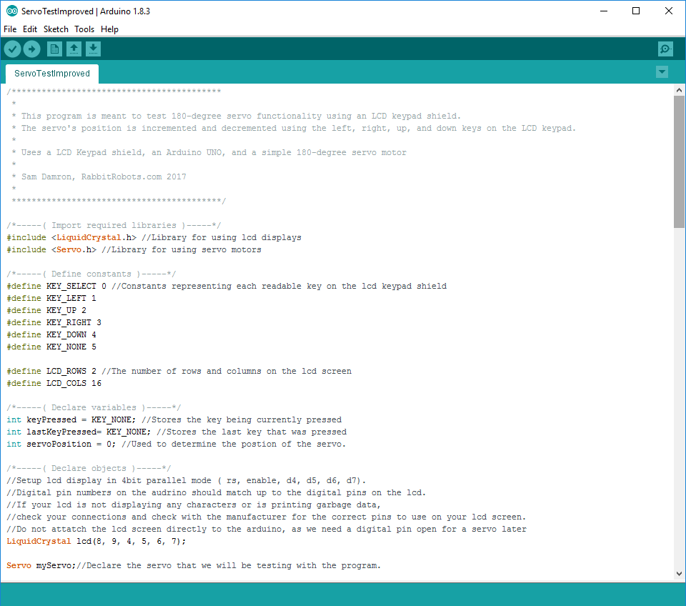
The second section (fig. 3) is the setup() method that runs once when the UNO starts up. In here, the lines “pinMode(3, OUTPUT);” and “myServo.attach(3);” setup the servo to be used by the Arduino on digital pin three. “pinMode(3, OUTPUT);” sets digital pin 3 to output mode so it can send commands to the servo, and “myServo.attach(3);” states that the servo declared earlier is going to be used on digital pin three.

fig.3
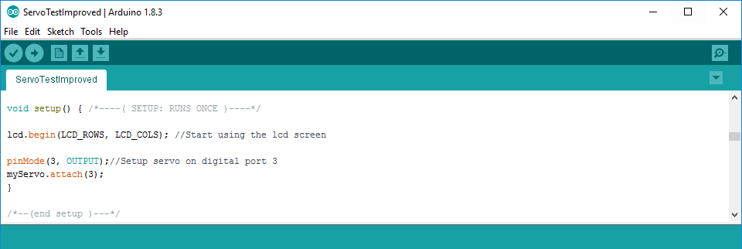

The third section (fig. 4) is the loop() method that runs continuously on the UNO once setup()is completed. A majority of this section deals with responding to keypad presses and displaying data on the LCD, but servo routines are also handled here. The first servo-related line is “servoPosition += 10;” within the if-statement for when the UP key is pressed. What this line does is increase the current value of servoPosition by ten, and could be written instead as:
“servoPosition = 10 + servoPosition;”
The next servo-related line is “servoPosition -= 10;” which does almost the same thing as the first line, but it subtracts the value of servoPosition by ten instead. Likewise, it could also be written as:
“servoPosition = 10 - servoPosition;”
The lines “servoPosition++;” and “servoPosition--;” work similarly, except that they change the value of servoPosition by one instead of ten. The “++” and “--” notations are used especially for increasing (incrementing) and decreasing (decrementing) the values of variables by 1.
At the end of the key-detecting section of the loop() method is the line:
“servoPositon = constrain(servoPosition, 0, 180);”
This line limits the value of servoPosition to between 0 and 180. If the value is below or above this range, it is set to either 0 or 180 depending which it is closer to. This is important as the servo should only be able to go from 0° to 180° and setting it anywhere beyond that may damage it.
Lastly, “myServo.write(servoPosition);” at the end of loop() sets the servo to go to the position stored in servoPosition.

fig. 4
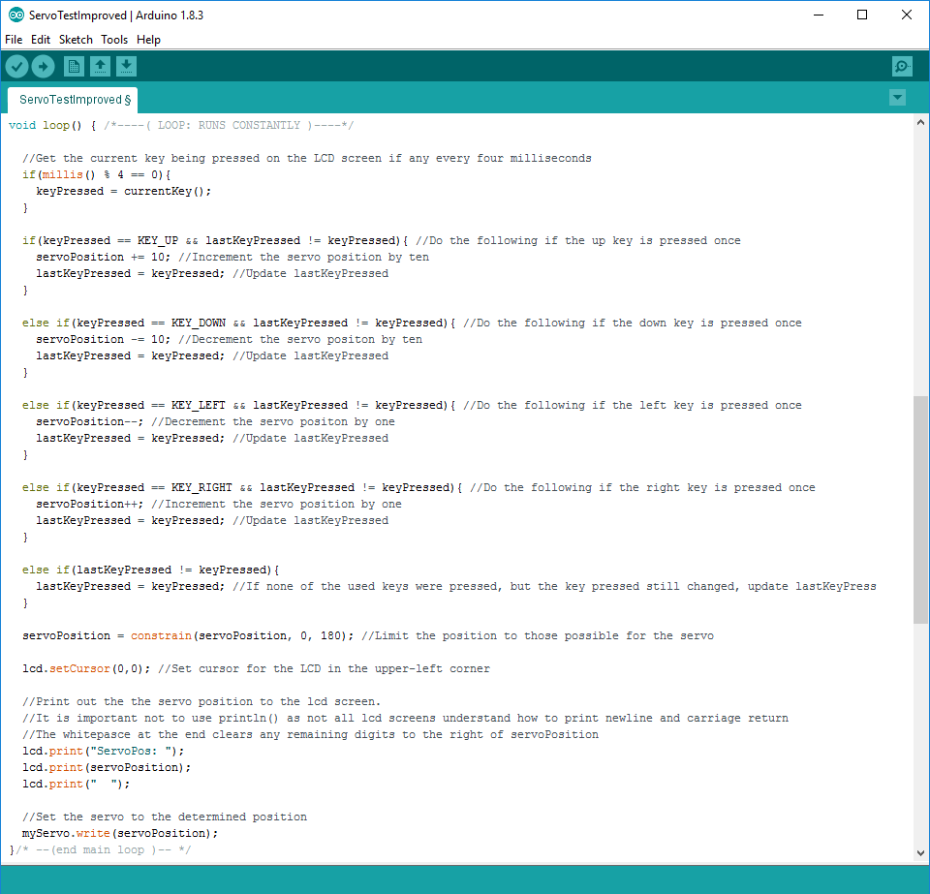

Extension:
Attach additional servos to the UNO on digital pins 10-13 and edit the program to try to control them as well.
Have the servo move back and forth using the built-in delay(milliseconds) method in the main loop.
Use serial communication with the UNO to control the servo instead of the LCD keypad.

